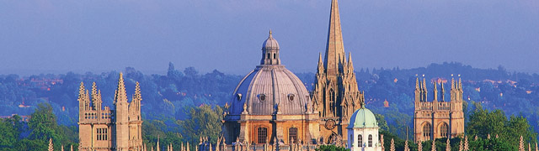

HAEMATOLOGY IN OBSTETRICS POSTGRADUATE COURSE

Monday 24 September to Wednesday 26 September 2018

St Edmund Hall
The Doctorow Hall, Queen’s Lane Oxford OX1 4AR

This is an intensive, enjoyable Postgraduate Course on Haematology in Obstetrics.

The course includes didactic teaching on major topics together with interactive sessions and workshops.

Places are limited to 25 to optimise learning and interaction: Allocation is by first come basis.
The programme leads are
Dr Sue Pavord, Mrs Helena Maybury
Department of Haematology, Oxford University Hospitals Department of Obstetrics, University Hospitals of Leicester
Sue.pavord@ouh.nhs.uk Helena.J.Maybury@uhl-tr.nhs.uk

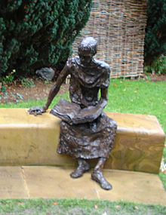
St Edmund became Archbishop of Canterbury in 1233, and was canonised 6 years after his death in 1246.
His feast day is 16 November
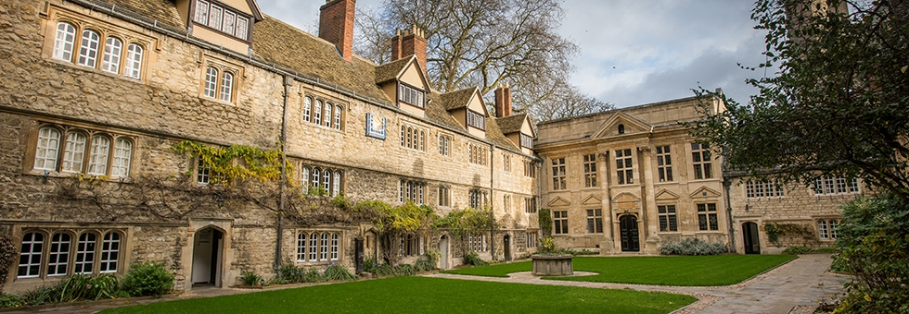St Edmund Hall (known as Teddy Hall) is a college of the University of Oxford. It retains its ancient title of 'Hall', which dates back to the thirteenth century, and is the last surviving medieval hall at the University

For further course information:
Email: sue.pavord@ouh.nhs.uk
Phone: 07712 621526

Please send application forms to:

Miss Joyce Dyer

Oxford University Hospitals NHS Foundation Trust

Department of Haematology, Level 4,

John Radcliffe Hospital, Headington, Oxford OX3 9DU

Email: joyce.dyer@ouh.nhs.uk

Registration Fee includes lunches & refreshments,

course dinner, and

early morning fun run.

£470 before 01.07.18

£490 from 02.07.18 to 1.08.18

£520 from 02.08.18

Places will be allocated on a first come basis and attendance will be conditional upon advance payment being received.
A charge may be made for cancellations

Accommodation is available at William Miller Building in Dawson Street, with breakfast at St Edmund’s, at a cost of £45 per room and can be booked by contacting:
Sue McCarthy, Conference Manager
Email:susan.mccarthy@seh.ox.ac.uk

Websites:

St Edmund Hall
www.seh.ox.ac.uk

Oxford Tourist Information www.visitoxfordandoxfordshire.com

Reservation Form
Haematology in Obstetrics Postgraduate Course
Getting to Oxford
Oxford is about 60 miles (90 kms) northwest of London and has excellent road and national rail links.
- From London: options include train or bus. Trains leave regularly from London Paddington (enquiries: 08457484950; www.nationalrail.co.uk ). For buses, options include the Oxford Tube (enquiries: 0(044)1865772250) / Oxford Express (enquiries: 0(044)1865785410), which leave every 12 minutes during peak times. Coaches stop along the High St at intervals and end at Gloucester Green Coach Station in the city centre.

- From London airports: if travelling from Heathrow or Gatwick, use The Airline coach service, which operates a direct frequent service twenty-four hours a day. For information telephone 0(044)1865 785400. London Stansted airport is linked to Oxford by the National Express 757 coach service, running every two hours (tel: +44 (0)8705 747777).

- By car: We recommend public transport for travelling to Oxford, as many Oxford streets are now closed to traffic and parking is limited. To find out more about parking in Oxford please go to the council website, There is a Park and Ride bus services which operate between the city centre and parking areas on the outskirts of the city.

- Taxis Taxis can be found at Gloucester Green Coach Station, Oxford Railway Station, and St Giles' in the city centre. Some taxi numbers: Radio Taxis, Tel: 0(044)1865 249743 or 242424 or ABC Taxis, Tel: 0(044)1865 770077.

.

Please submit payment as soon as possible to secure your place.
BACs Payment
Account | HAEMOBS
Bank | Barclays
Sort Code | 20 49 17
Account No | 43185982
IBAN GB62 BARC 2049 1743 1859 82
SWIFTBIC: BARCGB22
Surname
Forename
Job Title
Hospital Address
Post Code
Tel No
Mobile
Email | 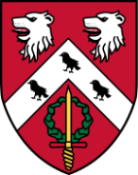
I wish to attend the evening meal on Tuesday, 25th September Yes/No
I would like to participate in the Course Fun Run in Oxford City Centre on Wednesday, 26th September
at 7.am Yes/No

